AI FAQ Assistant API
(AI-powered FAQ and customer support automation)
Item | Details
Project Title | AI FAQ Assistant API
Submitted By | Team leader: Vasanthi M [sac2427csc5196@ssacollegechennai.com ]  Team members: Yuvashree p [sac2427csc5430@ssacollegechennai.com ]  Vidhuna N[sac2427csc5516@ssacollegechennai.com ]  Yamini S [sac2427csc5301@ssacollegechennai.com ]  Yoshine L [sac2427csc5409@ssacollegechennai.com ]
Guide / Institution | ST. Anne’s Arts and science college
Demo Video | https://drive.google.com/file/d/1MnngwvoYD4rMkXHMrvOhtp4iIpMyUTgl/view?usp=drive_link

1. PROJECT INTRODUCTION
The AI FAQ Assistant is a robust, secure, and intelligent REST API platform designed to streamline FAQ creation, user authentication, and AI-powered content management. Built with Node.js and Express.js, the application utilizes MongoDB as its primary data store along with Mongoose ODM for elegant data modeling and schema validation.
Security is central to the architecture, implementing JWT (JSON Web Tokens) for stateless user sessions and route guarding alongside bcrypt for strong password encryption. The backend handles intensive operations like automated FAQ generation, semantic search queries, and dynamic context parsing. It also features robust centralized error handling and response status sanitization to prevent unhandled database leakage and ensure operational durability.

2. PROBLEM STATEMENT
Many organizations receive repeated questions from customers and users. Handling these questions manually can take considerable time and effort. Traditional FAQ systems also require users to search for the required information themselves.
The proposed system provides an API-based solution for FAQ management and AI-powered answer generation. It reduces repetitive work and provides a structured way to manage frequently asked questions.
3. OBJECTIVES OF THE PROJECT
The main objectives of the AI FAQ Assistant API are:
- To develop a REST API for FAQ management.
- To provide secure user authentication.
- To store FAQ information in MongoDB.
- To generate FAQs using Google Gemini AI.
- To generate AI-based answers for user queries.
- To protect API routes using JWT authentication.
- To provide secure password storage using bcrypt.
- To simplify customer support activities.
- To provide structured API responses.
- To test and demonstrate the API using Thunder Client.

4.TECHNOLOGIES USED:
The AI FAQ Assistant API is developed using the following technologies:
- Node.js – Backend runtime environment.
- Express.js – Framework for developing REST APIs.
- MongoDB – Database for storing application data.
- Mongoose – ODM used to interact with MongoDB.
- JWT (JSON Web Token) – Used for secure user authentication.
- bcrypt – Used for securely hashing passwords.
- Google Gemini AI – Used for AI-powered FAQ and answer generation.
- JavaScript – Programming language used for backend development.
- Thunder Client – Used for testing and demonstrating API requests and responses.

5. SOFTWARE REQUIREMENTS:
  - Operating System: Windows 10/11, macOS, or Linux (supports cross-platform operations).
  - Node.js (v18 or above): Runtime ecosystem running server logic and routing infrastructure.
  - npm (v9 or above): Node package manager to control operational dependencies.
  - Express.js (v4/v5 Ecosystem): Lightweight routing web framework to construct backend RESTful entry points.
  - MongoDB / Mongoose ODM: Document NoSQL engine storing application users and curated data entities.
  - Postman / Thunder Client: API verification toolkit to assert schema validation responses across administrative route shields.
  - Code Editor: Visual Studio Code or similar IDE environment.

6. HARDWARE REQUIREMENTS
  - Processor: Intel Core i5 (8th Gen or above) / AMD Ryzen 5 or equivalent.
  - RAM: 8 GB minimum (16 GB recommended for concurrent instances of MongoDB processing layers).
  - Storage: 1 GB of available disk workspace.

7.PROJECT ARCHITECTURE
The system uses a layered server architecture: every request passes through parsing, authentication and validation before reaching the business logic and the database.
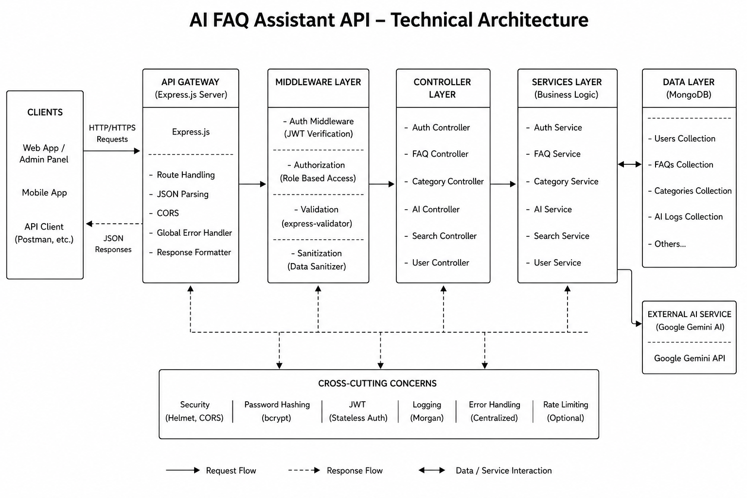
Figure 1: Technical architecture
Components: Express gateway (routing, JSON parsing, CORS); authentication middleware (JWT verification); services (business rules); Mongoose (database layer); Gemini service (AI generation); cross-cutting concerns (security, hashing, error handling, optional rate limiting).

8. USER FLOW DIAGRAM

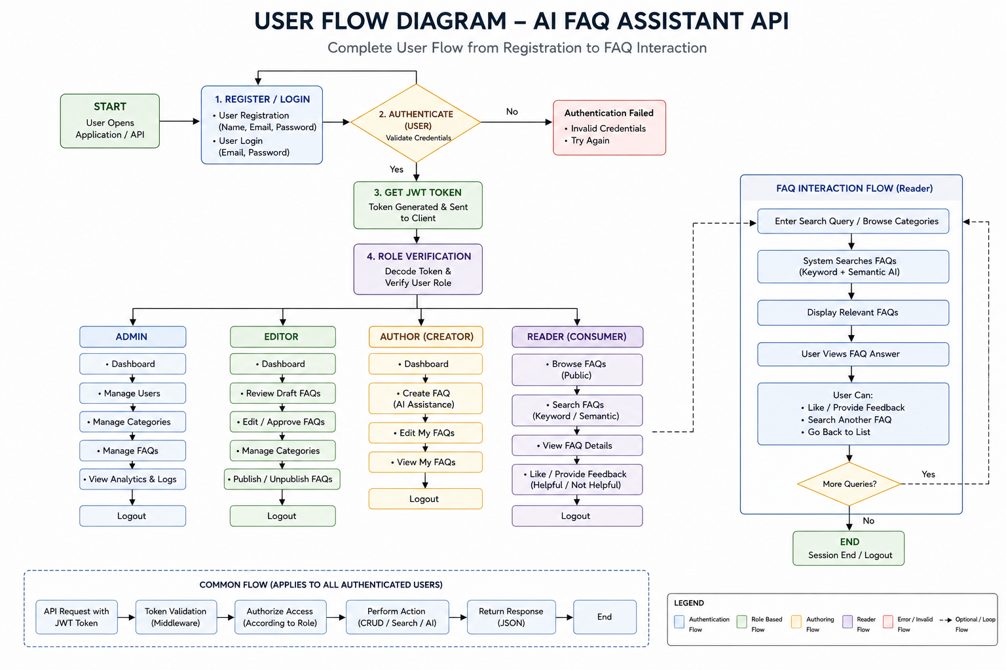
Figure 4: User flow from registration to FAQ interaction
A user registers or logs in, receives a JWT, the role is verified, and every request follows the same path: token validation → role authorization → action (CRUD / search / AI) → JSON response.

9. PROJECT MODULES

The AI FAQ Assistant API consists of several modules that work together to provide secure FAQ management and AI-powered customer support.

- Authentication Module
This module manages user registration and login. It uses bcrypt for password hashing and JWT for secure authentication and protected API access.

- FAQ Management Module
This module allows users to create, view, update and manage frequently asked questions. FAQ data is stored securely in the MongoDB database using Mongoose.

- AI Answer Generation Module
This module uses Google Gemini AI to generate relevant answers for user questions. It helps automate customer support and reduces repetitive manual responses.

- AI FAQ Generation Module
This module generates frequently asked questions and answers using the provided content or context. It helps users create FAQ content quickly using AI.

- Security Module
The security module protects user information and API routes. JWT authentication is used for route protection, while bcrypt is used to securely store passwords.

- Error Handling Module
This module handles application and API errors and provides clear JSON responses. It helps identify problems and ensures that the application responds properly to invalid requests.

- Database Module
The database module manages application data using MongoDB and Mongoose. It provides structured storage and retrieval of user and FAQ information.

- API Management Module
This module manages REST API routes and handles communication between the client, backend services, database and AI services. It provides structured JSON responses for API requests.

10. API Routes
Method | Endpoint | Access | Purpose
POST | /api/auth/register | Public | Register user
POST | /api/auth/login | Public | Login, get JWT
GET | /api/auth/profile | Private | View profile
GET | /api/faqs, /api/faqs/search?q=, /api/faqs/:id | Public | List, search, view FAQ
POST | /api/faqs | Private | Create FAQ
PUT / DELETE | /api/faqs/:id | Private (owner) | Update / delete FAQ
POST | /api/ai/answer, /api/ai/generate-faq | Private | AI answer / AI FAQ

11. PROJECT EXECUTION PROCESS
The project is executed using Node.js and Express.js. The application connects to MongoDB for database operations and uses Google Gemini for AI-based functionality.
Execution Steps
- Open the project in Visual Studio Code.
- Install the required Node.js packages.
- Configure the environment variables.
- Connect the application to MongoDB.
- Start the Node.js server.
- Access the API endpoints.
- Authenticate the user when required.
- Send API requests through Thunder Client.
- Process the request using the appropriate module.
- Generate the required response.
- Display the API response in Thunder Client.

12.PROJECT DEMONSTRATION

  - Server Execution
- The Node.js server is started successfully and the API is made available for testing.
- The server status is verified using the terminal and API root response.
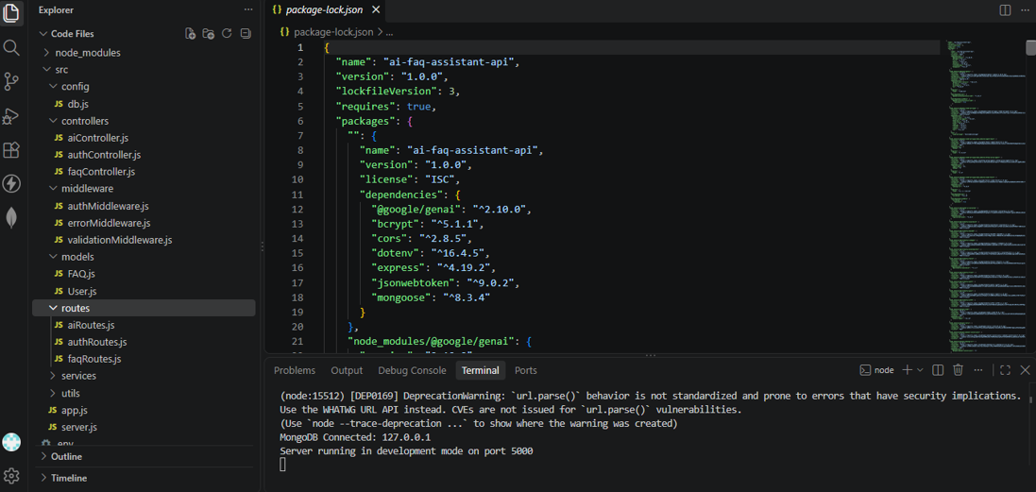
12.2 API Testing Using Thunder Client
- The API endpoints are tested using Thunder Client by sending different requests.
- The JSON responses are verified to ensure that the APIs are working correctly.
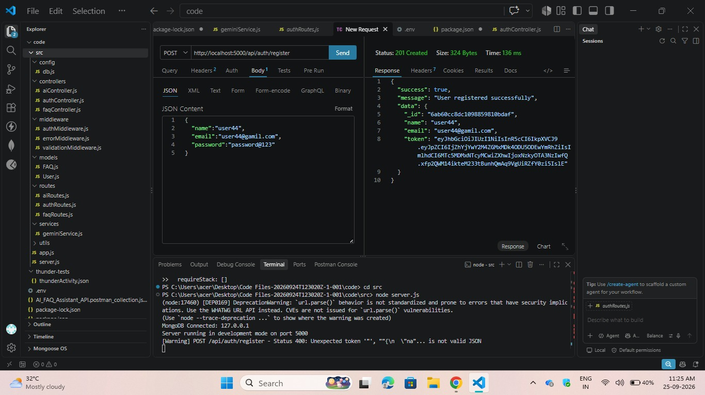

12.3 Database Demonstration
- MongoDB Compass is used to verify the data stored by the application.
- User and FAQ records are checked to confirm successful database storage.
- 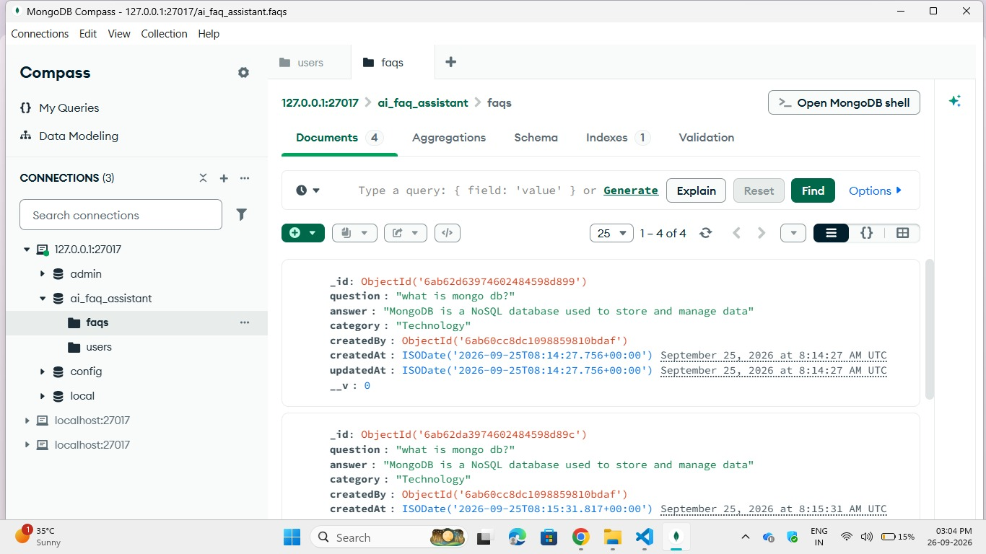

12.4 AI Feature Demonstration
- The AI endpoints are tested to generate answers and FAQs using the AI service.
- The generated JSON responses are verified to demonstrate the AI functionality.

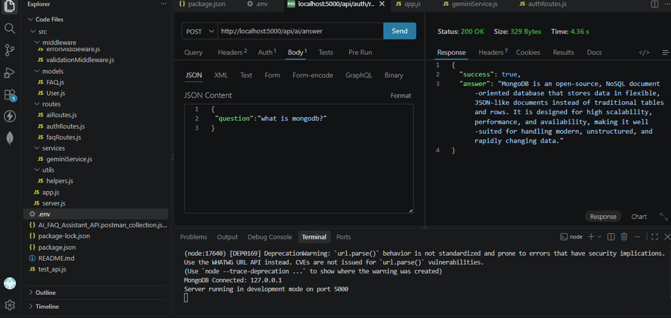

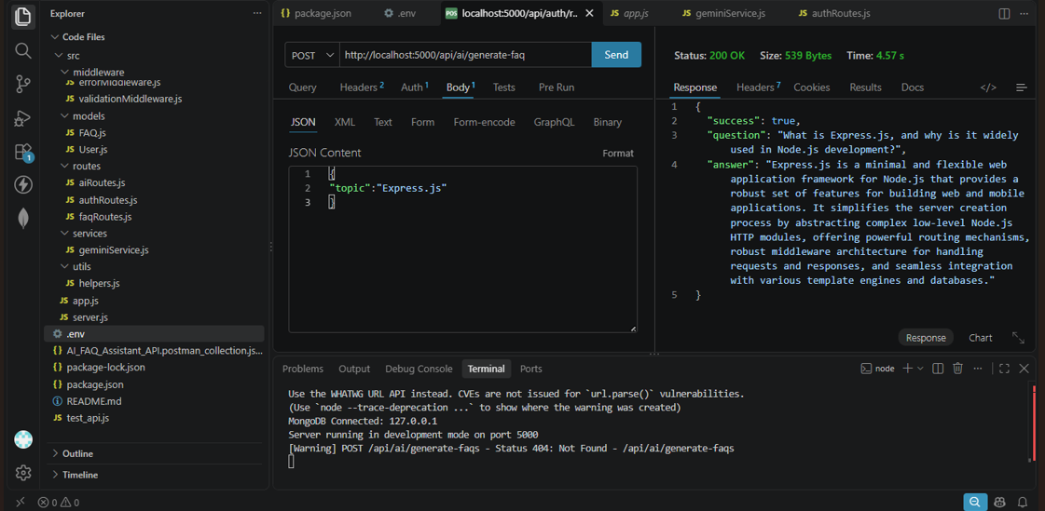

13. ADVANTAGES

- Reduces repetitive customer support work by providing automated responses.
- Provides AI-powered answers using Google Gemini.
- Makes FAQ creation and management easier.
- Provides secure authentication using JWT and bcrypt.
- Uses MongoDB for structured and reliable data storage.
- Provides reusable REST API endpoints for different applications.
- Can be easily tested using Thunder Client.

14. APPLICATIONS

- Educational institutions for answering common student queries.
- E-commerce websites for product and order-related questions.
- Customer support systems for automated assistance.
- Company help desks for employee and customer support.
- Service-based businesses for answering service-related queries.
- Online platforms for providing automated information.
- Product support systems for handling frequently asked questions.

15. LIMITATIONS

- AI responses depend on the quality of the provided information.
- Internet connectivity is required for Google Gemini integration.
- Protected operations require proper user authentication.
- The project does not currently include a complete graphical interface.
- AI functionality depends on the availability of the configured AI service.
- Proper database and environment configuration is required.
- AI-generated responses may vary depending on the user's input.

16. FUTURE ENHANCEMENTS

- A complete web-based frontend can be developed.
- An admin dashboard can be added for FAQ management.
- A chatbot interface can be integrated for real-time interaction.
- Voice-based question and answer functionality can be introduced.
- Multi-language support can be added for different users.
- Analytics and reporting features can be developed.
- The system can be integrated with websites and customer support platforms.
17. PROJECT OUTPUT

- The AI FAQ Assistant API is successfully developed using Node.js and Express.js.
- User registration and login functionality are implemented with secure authentication.
- FAQ data is successfully created, managed, and stored in MongoDB.
- Protected API endpoints are accessed using JWT-based authentication.
- AI-based answer and FAQ generation features are implemented using Google Gemini.
- API requests and JSON responses are successfully tested using Thunder Client.
- The completed backend provides a reusable API that can be integrated with frontend applications and other platforms.

18. CONCLUSION

- The AI FAQ Assistant API was successfully developed as a backend application using Node.js and Express.js.
- The system provides secure user registration and login functionality using JWT and bcrypt.
- FAQ information can be created, managed, and stored efficiently using MongoDB and Mongoose.
- Google Gemini AI is integrated to support AI-based answer and FAQ generation.
- REST API endpoints provide an organized way for clients to communicate with the backend.
- Thunder Client was used to test the API requests and verify the JSON responses.
- Overall, the project provides a reusable and efficient backend solution for FAQ management and AI-powered customer support.

19. REFERENCES

- Node.js Official Documentation – Backend JavaScript runtime and development concepts.
- Express.js Official Documentation – REST API and server-side development.
- MongoDB Official Documentation – Database and data management concepts.
- Mongoose Documentation – MongoDB object data modelling and schema management.
- Google Gemini API Documentation – AI-based content and response generation.
- JSON Web Token (JWT) Documentation – Authentication and authorization concepts.
- Thunder Client Documentation – API testing and request-response verification.

